0000.doc

PHYSICS 3APHY and 3BPHY

Formulae and Constants Sheet

Physics 3A/3B: Formulae and Constants Sheet



Forces and Motion
Mean velocity | 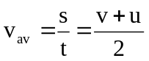
Equations of motion | 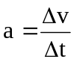 ; 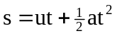 ; 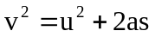; 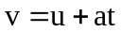
Force | 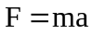
Weight force | 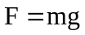
Momentum | 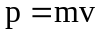
Change in momentum (impulse) | 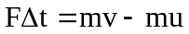
Kinetic energy | 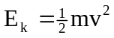
Gravitational potential energy | 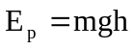
Work done | 
Power | 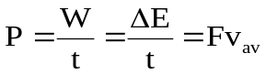
Centripetal acceleration | 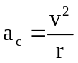
Centripetal force | 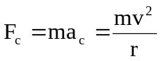
Newton’s Law of Universal Gravitation | 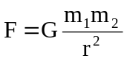
Gravitational field strength | 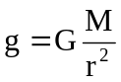
Moment of a force | 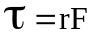

Electricity and Magnetism
Electric current | 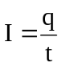
Electric field | 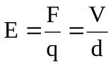
Work and energy | 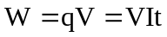
Ohm’s Law | 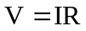
Resistances in series | 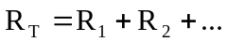
Resistances in parallel | 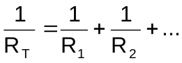
Power | 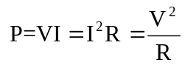
Magnetic flux | 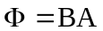
Electromagnetic induction | 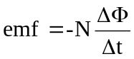, 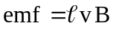
Magnetic force | 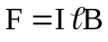 , 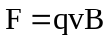
Ideal transformer turns ratio | 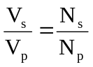

Particles and waves
Energy of photon | 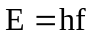
Energy transitions | 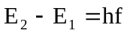
Wave period | 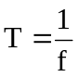
Wave equation | 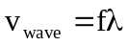
Internodal distance | 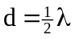
Absolute refractive index | 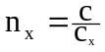
Snell’s Law | 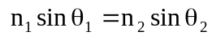

Physical Constants
Speed of light in vacuum or air c = 3.00 x 10⁸ m s⁻¹
Electron charge e = -1.60 x 10⁻¹⁹ C
Mass of electron m_{e} = 9.11 x 10⁻³¹ kg
Planck's constant h = 6.63 x 10⁻³⁴ J s
Universal gravitational constant G = 6.67 x 10⁻¹¹ N m² kg⁻²
Electron volt 1 eV = 1.60 x 10⁻¹⁹ J
Mass of proton m_{p} = 1.67 x 10⁻²⁷ kg
Mass of alpha m_{α} = 6.65 x 10⁻²⁷ kg

Physical Data
Mean acceleration due to gravity on Earth g = 9.80 m s⁻²
Mean acceleration due to gravity on the Moon g_{M} = 1.62 m s⁻²
Mean radius of the Earth R_{E} = 6.37 x 10⁶ m
Mass of the Earth M_{E} = 5.98 x 10²⁴ kg
Mean radius of the Sun R_{S} = 6.96 x 10⁸ m
Mass of the Sun M_{S} = 1.99 x 10³⁰ kg
Mean radius of the Moon R_{M} = 1.74 x 10⁶ m
Mass of the Moon M_{M} = 7.35 x 10²² kg
Mean Earth-Moon distance 3.84 x 10⁸ m
Mean Earth-Sun distance 1.50 x 10¹¹ m
Tonne 1 tonne = 10³ kg = 10⁶ g

Electromagnetic spectrum
 |  | Wavelength
λ (m) |  |  |  |  |  |  |  |  |  | 10² |  |  |  | 10 |  |  |  |  |  | 1 |  |  |  |  |  |  |  |  |  | 10⁻¹ |  |  |  | 10⁻² |  |  |  | 10⁻³ |  |  |  |  |  | 10⁻⁴ |  |  |  | 10⁻⁵ |  |  |  | 10⁻⁶ |  |  |  | 10⁻⁷ |  |  |  |  |  |  |  | 10⁻⁸ |  |  |  |  | 10⁻⁹ |  |  |  |  | 10⁻¹⁰ |  |  |  |  | 10⁻¹¹ |  |  |  |  |  | 10⁻¹²
Area of  Spectrum |  |   microwaves  radio frequencies  infrared radiation  ultraviolet  radiation  X-rays  gamma rays
f(Hz) |  |  |  |  |  |  | 10⁶ |  |  |  |  |  | 10⁷ |  |  |  | 10⁸ |  |  |  |  |  |  |  |  |  |  |  | 10⁹ |  |  |  | 10¹⁰ |  |  |  | 10¹¹ |  |  |  |  |  | 10¹² |  |  |  | 10¹³ |  |  |  | 10¹⁴ |  |  |  | 10¹⁵ |  |  |  |  |  |  |  | 10¹⁶ |  |  |  | 10¹⁷ |  |  |  |  |  | 10¹⁸ |  |  |  |  | 10¹⁹ |  |  |  |  |  | 10²⁰
 | Frequency

Note: 1. Shaded areas represent regions of overlap.
2. Gamma rays and X-rays occupy a common region.

Prefixes of the Metric System
Factor | Prefix | Symbol | Factor | Prefix | Symbol
10¹²  10⁹  10⁶  10³ | tera  giga  mega  kilo | T  G  M  k | 10⁻³  10⁻⁶  10⁻⁹  10⁻¹² | milli  micro  nano  pico | m  µ  n  p

Mathematical expressions

Given 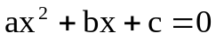, 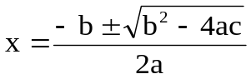

The following expressions apply to the triangle ABC as shown:  B  C  A  c  a  b | The following expressions apply to the right-angled triangle ABC as shown:  B  C  A  c  a  b
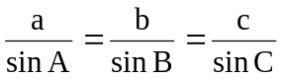 | 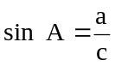
 | 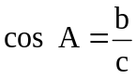
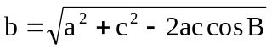 | 